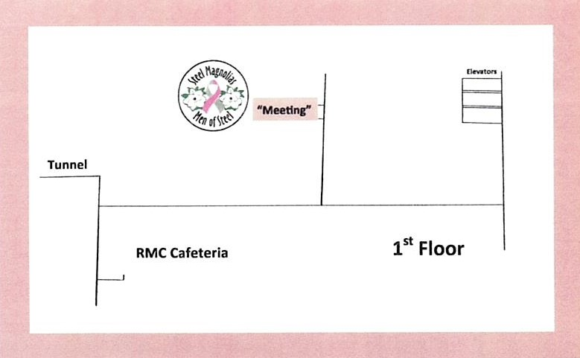February 27th is our next Steel Magnolias meeting in the private dining room at RMC. RMC will provide our meal and we will have baked sweet and Irish potatoes; Steel Magnolias, please bring side dishes and desserts. Our very own Walter Lawson will be our guest speaker. He will share the types of services the Chaplain’s office provides. Everyone, please plan to attend and bring a friend!